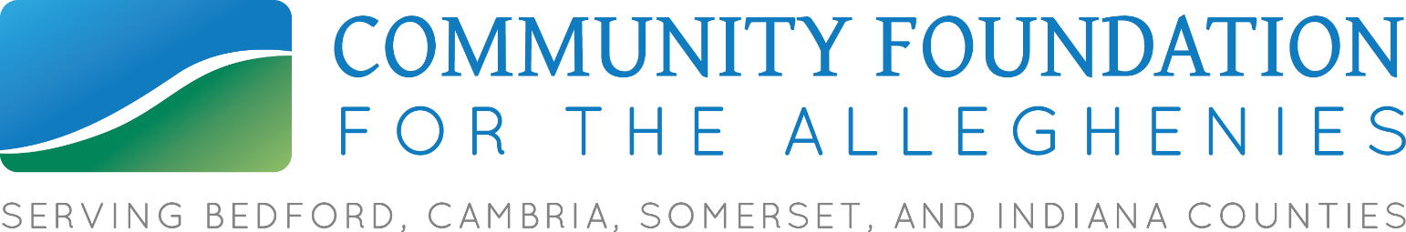
DATE, 2020 Contact: Communications Officer Kecia Bal
For Immediate Release (814) 208-8394 / kbal@cfalleghenies.org

JARI Launches Non-Traditional Scholarships Aimed at Helping Young Adults

JOHNSTOWN—JARI is now accepting applications for a new scholarship program aimed at providing local young people, ages 16 – 30, with new career opportunities through short-term training programs. The goal is to create opportunities for at least 22 young people who do not have post-secondary education and place at least 20 of them into employment and new careers.

The Supporting Youth Education and Employment project, funded with a $40,000 Community Initiatives Fund grant from Community Foundation for the Alleghenies (CFA), will provide two scholarship types: $2,500 to cover short-term training programs in in-demand fields and $300 stipends for high school students participating in work-based experience programs, or co-ops.

The scholarships respond to a trend over the past 15 years: Many times, young people move directly into employment after high school and find themselves stuck in low-wage jobs with limited career opportunities because they have no post-secondary education. The broad economic hardships of this year, especially on restaurant and retail industries, have made this project even more critical, JARI Workforce Development Director Debra Balog said.

“When we look at developing an opportunity for this group, we’d normally be thinking of 16- to 26-year-olds,” she said. “We decided to extend it out to the age of 30 because of the situations the pandemic has created. When there’s an economic downturn, our out-of-school youth and young adults are probably one of the most vulnerable populations.”

With this program, options will be built from individual applicant’s area of interest and matched with in-demand jobs—rather than offering a series of specific training programs. Industries such as healthcare, trades, manufacturing, and information technology continue to be promising career options in the region.

“We will be providing a variety of options based on employers’ needs and the individual’s career paths,” Balog said. “If they’re interested in completing a short-term training program and if it is an in-demand occupation, then they can be considered for one of the 12 scholarships.”

The programs could vary from 9 weeks up to 6 months. Applications are available by visiting jari.com or by calling (814) 262-8366. Scholarships will be awarded on a rolling basis as long as funds are available. All participants will be required to complete at least 4 hours of community service.

Balog added that she is confident these young people can be matched with local job opportunities, and that JARI’s surveys show that many local employers have indicated that they will continue hiring in 2021.

“Overall, our goal is to increase the labor force participation rate,” she said. “Developing our youth is going to play a vital role in building our workforce capacity. We want to get as many people as possible trained with the skills needed to enter into the workforce.”

JARI also will be working with local school districts to distribute co-op stipends to students. Those are meant to help with ancillary costs associated with work experience. The last time JARI implemented a co-op stipend program, every participant successfully transitioned from high school to their new careers.

CFA President Mike Kane said the project aligns perfectly with the economic goals of the Foundation’s Community Initiatives Fund.

“Community Initiatives focuses on creating a brighter future for our region by focusing on beautifying and place-making as well as achieving economic goals, such as creating job opportunities,” he said. “These scholarships can and will change lives, and we’re thankful to the donors who have the vision to see how important our workforce—and increasing access to viable careers—is to individual families and our community’s future.”

