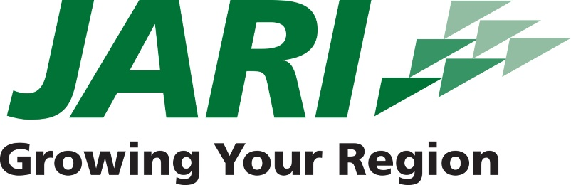

FOR IMMEDIATE RELEASE CONTACT
October 12, 2015 Debi Balog
Director of Workforce Development
(814) 262-8366
dbalog@jari.com

Fourteen Regional School Districts to Participate in Fourth Annual Youth Professional Development Conference

JOHNSTOWN, PA – More than 150 students from fourteen school districts in the greater Johnstown area will have the opportunity to learn from and interact with top professionals in the fields of education, manufacturing, marketing, human resources, and more during the Fourth Annual Youth Professional Development Conference on Thursday, Oct. 15, 2015 at the Frank J. Pasquerilla Conference Center. Hosted by the Human Resources Association of the Alleghenies (HRAA) in association with JARI, the conference will feature a keynote speaker, lunch, and four individual sessions on a variety of topics.

“We are thrilled to partner with JARI to host this conference,” said Tonia Gordon, president of HRAA. “This is a unique opportunity for high school students to engage with and learn from our region’s business leaders and human resources professionals. Our goal is to engage and inspire our youth to plan now for their future.”

Dr. Roger L. Briscoe, a current faculty member in the Department of Educational and School Psychology at Indiana State University, will serve as this year’s keynote speaker and lead a session that examines the tools necessary for future success.

Students will also hear from Brian Law and Shelley Johansson of Prime Design Solutions on how to effectively utilize social media for work and educational purposes. Chief Executive Officer of JWF Industries and JWF Defense, William C. Polacek, will provide insight into developing leadership skills and becoming an entrepreneur. Amy Horwath, a member of the Conference Planning Committee who currently serves as Campus Director of Cambria-Rowe Business College, will give a presentation on emotional intelligence, helping students to better understand the connection between emotions and professional success.

ABOUT JARI
JARI is a non-profit economic development organization that has been a devoted partner of the business community in Cambria and Somerset Counties since 1974. JARI’s team of business professionals has a combined 155 years of experience in economic and entrepreneurial development. Our agency provides value-added services and connections to the right people in government, commercial lending, equity investing, real estate and other regional, state and federal economic development groups.

###

