Company Readiness Evaluation
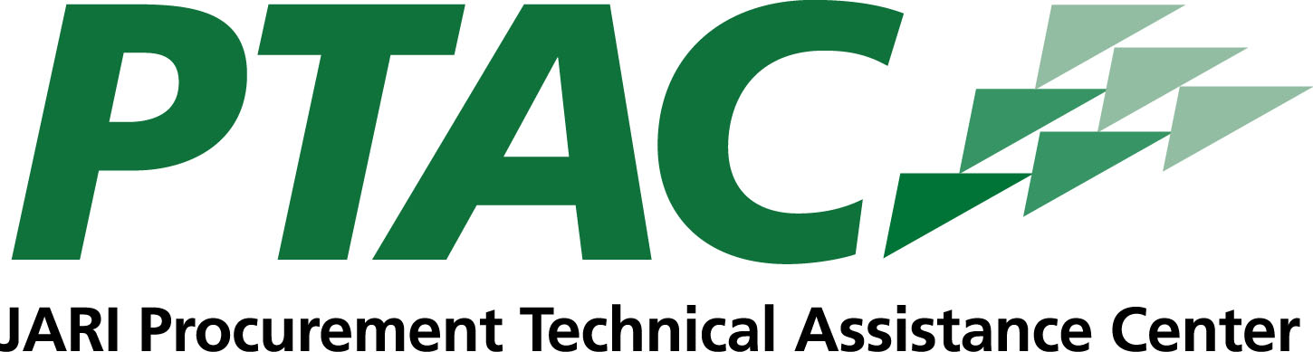
- Do I have several satisfied clients in my commercial sector “past performance portfolio” that will vouch for me?
If you do not have a business license, you are not ready to sell to the government. If you do not have an established business with a history of sales, you are not ready to sell to the government.
- Do I have a current business plan that has a “fit” for government contracting?
Small businesses need to properly align their business plan to address the specifics of the government market. Insurance and, where required, surety bonding are essential if planning to do business with government agencies.
- Do I want to, or can I, effectively compete against incumbents in my specific government market niche? Do I have the extra capacity to provide the government with cost-effective, quality, and on time goods and services?
Are you prepared to do proper market research and analysis to determine if the government buys your product or service? If so, which agencies or departments are you going to target your sales towards? If awarded contracts, will I be able to perform?
- Does my current and projected cash flow allow for a significant time lapse (often 1-2 years or more) before I get my first government purchase?
It can take longer to receive payment for government work — sometimes up to 30 to 45 days after the work is completed. Can you cover your overhead until the payment arrives?
- Can I get contract financing readily when I need it?
Do you have sufficient financial resources and cash flow to handle current obligations as well as those you would encounter under a government contract?
- Can I do electronic commerce for researching, bidding, invoicing, receiving payment, etc? Will I need to accept government purchase cards?
Having a website that supports e-commerce is an increasingly important factor in your ability to win and perform on contracts. This often includes accepting credit card payments.
- Are my quality systems adequate for what my government buyers want?
Government contractors are required to meet all criteria necessary to do business within their region, include abiding by all regulatory and licensing requirements.
- Am I better off subcontracting?
Often, requirements are such that small businesses have better opportunities subcontracting for a prime.
245 Market Street, Suite 200, Johnstown, PA 15901
www.jari.com

